Michigan Tech
MEEM 5250: Internal Combustion Engines II
Assignment 05
Individual Assignment

SI Combustion Analysis (Part B)

Instructor: Dr. J.Naber
Office: MEEM 1011
Email: jnaber@mtu.edu
Tel: 906.487.1938

GTA: Ehsan Ansari
Email: eansari@mtu.edu
Office: 708 MEEM

Date Assigned: October 22, 2013

Dates Due: Parts I-III October 30, 2013 11:00AM
Parts IV-VI November 4, 2013 11:00 AM

Instructions: This is an individual HW assignment to be turned in at the beginning of class (paper copy) and into Canvas (electronic copy).

Overview: In part (A) Cycle Simulation in Assignment 3 we looked at the process to estimate the cylinder pressure given simple combustion models and compute performance parameters (indicated work, efficiencies, etc.). Here we reverse that process and utilize measured cylinder pressure to determine combustion and performance parameters.

Cylinder pressure analysis is the primary method of determining combustion characteristics in the engine laboratory. The measurement requires accurate phased measurement of the cylinder pressure in conjunction with engine position. Knowing engine position (crank-angle) and engine geometry one can determine engine volume (Heywood [1] section 2.2). From the pressure volume relationship indicated cycle work can be determined (Heywood section 2.4). Assuming a closed system, ideal gas and applying the first law a simple ODE for apparent heat release can be obtained as (Heywood section 9.2)

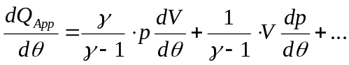 . Eq 1 / Hewood Eq 9.27

Ignoring crevice and heat transfer effects, we get a simple ODE for the apparent heat release (Q_{App}). From discrete data sampled synchronously (1, 2, …, i-1, i, i+1, …, n) with engine position at a fixed crank angle (Δθ), and approximating the derivatives with a central difference one can obtain the following equation

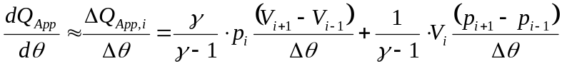 . Eq 2
This assignment is to apply this analysis to determine combustion characteristics of a modern engine.
Engine and Data:
The engine specifications are given in Table 1. The data is stored in Matlab “MAT” format with the variable specifications given in Table 2. For each test point there are 300 cycles of data (CA from -180 to 540 °ATDCF.
Table 1: Engine Specifications
Ecoboost iVCT V6
Bore (m) | 0.0925
Stroke (m) | 0.0867
Compression Ratio | 10.0:1
Displacement (L) | 3.496
Firing Order | 1-4-2-5-3-6

Table 2: Matlab data specification

Variable | Unit | Description
CA | CAD | Crank Angle
MAP | kPa | Manifold Absolute Pressure
P | kPa | Cylinder Pressure: non-referenced
T | msec | Time
VOL | cm³ | Cylinder volume

A series of test were performed where cooled exhaust gas was recirculated (EGR) a levels from 0 to 30%. The test matrix and associated test number which links to the MAT data file are given in Table 3.
Table 3. Test Matrix
TEST | Speed  (rpm) | BMEP  (bar) | EGR  (%) | Comments | SA (dATDC)
622 | 1500 | 2.62 | 0 | Baseline | -40.8
623 | 1500 | 2.62 | 6 | MBT | -29.4
624 | 1500 | 2.62 | 12 | MBT | -30.8
625 | 1500 | 2.62 | 16 | MBT | -35.8
626 | 1500 | 2.62 | 18 | MBT | -36.5
627 | 1500 | 2.62 | 20 | MBT | -40.0
628 | 1500 | 2.62 | 22 | MBT | -41.6
629 | 1500 | 2.62 | 24 | MBT | -45.6
630 | 1500 | 2.62 | 26 | MBT | -50.4
631 | 1500 | 2.62 | 28 | MBT | -53.7
632 | 1500 | 2.62 | 30 | MBT | -61.4
633 | 1500 | 2.62 | 0 | MBT | -25.0

Assignment:
Using the data from engine test conducted on a V6 3.5L Ford Ecoboost analyze the pressure - volume data. For the below perform analysis for tests 623, 626, and 631. Note figures and data are provided for Test 623. You should not expect to match these exactly as there are many parameters and methods one can apply within the guidelines of this problem. They are provided to assist you in solving (verifying your analysis) the problem and should be replaced by your answers.

Data investigation and plotting

Examine the data in tests and create a matlab function that loads the data and converts to SI units (m, kg, N, s).

Reference cylinder pressure (P) to manifold pressure (MAP) using function “ref_press.m”. Use a reference window just prior to bottom dead center compression CA = [530 to 540]°. Name the new referenced pressure “P_R”.

Examine cylinder pressure data and filter as needed (A simple filter should work fine. The data is relatively free of noise but has some digitization that can be improved with a properly selected filter. Note to use the “filtfilt” command so as not to introduce a phase delay.

For each test, plot (see figures next page for formatting and details)

Referenced cylinder pressure (bar) and MAP (bar) vs crank-angle (°) for all cycles at full scale

Referenced cylinder pressure (bar) and MAP (bar) vs crank-angle (°) for all cycles showing values near MAP (zoomed) for y-axis limits 0 to 2 bar.

Cylinder pressure (bar) vs volume for all cycles in log-log coordinates (use plot command “loglog”) with cylinder volume normalized by maximum volume. Plot referenced cylinder pressure (blue) and referenced and filtered cylinder pressure (red).

Introduce and discuss observations and comparisons of the tests based upon the plots

Create a cycle average of the cylinder pressure (from here on use referenced and filtered cylinder pressure for all analysis and plotting).

By reshaping the data you can create a matrix which can then be averaged over the appropriate dimension to create the cycle mean. Here is some code to start with
%% Cycle Data
% - 720 degree data with 1 degree resolution
n_cyl = floor(length(CA)/720);
n = n_cyl*720;
i_start = min(find(CA<-179));
ii = (0:n-1)+i_start;

P_RF_720 = reshape(P_RF(ii), 720, n_cyl);
P_RF_AVE = mean(P_RF_720, 2);

Plot individual and cycle average pressure vs crank-angle in the interval of -90 to 180 CAD for the three tests

Plot cylinder pressure (bar) vs volume for in log-log coordinates with cylinder volume normalized by maximum volume. Plot individual cycle cylinder pressure (blue) and average cycle cylinder pressure (red).

Discuss the figures and observations.

Compute indicated work from average cycle and complete table below. For COV you will have to calculate the IMEP for each cycle.
Parameter | Unit | Test 623  6% EGR | Test 626  18% EGR | Test 631  28% EGR
IMEP(GROSS) | (bar) | 3.47
COV(IMEPG) | (%) | 1.3
IMEP(NET) | (bar) | 2.86
IMEP(PUMP) | (bar) | 0.61
FMEP(Friction) | (bar) | 0.24

Compute the values of γ during compression and expansion by analysis prior to and after combustion using the relationship that pV^{γ} = constant. By applying a linear fit in the log(p) log(V) domain the slope of this curve is γ. Complete the following table based upon this analysis and discuss the trends in the table.

Parameter | Unit | Test 623  6% EGR | Test 626  18% EGR | Test 631  28% EGR
γ_{c} | (-) | 1.385
γ_{e} | (-) | 1.299

Compute the AHR and normalize to mass fraction burn (MFB) from the cycle average data.

Using equation 2, compute the AHR (Note in equation 2, γ can be a function of θ). Examine the effects of γ on the shape of the AHR curve by using different γ’s. As shown below in Figure V, γ changes the amplitude and offsets at the start and end of combustion. By matching the values to those determined from the log(p) vs log(v) values of compression and expansion figure on left-hand-side (LHS) as in part IV above and transitioning between them, a profile AHR that will be closer to zero before and after combustion can be developed.

By further tuning the values the AHR can be tuned to approach zero at the start and end of combustion as show by the figure on the right-hand-side (RHS). Include a figure like the RHS plot with the overally of the three AHR curves for the three tests in the same plot. You don’t need to show the results of AHR curves prior to
adjusting γ.

In the Figure V below, the curve on the left uses the γ of compression (gamma_{c}) and of expansion (gamma_{e}) transitioned using a running average filter with the following code.
% Define gamma (g)
CA_TRANS = 4.5;
N_TRANS = 10;
g = ones(size(CA));
g(CA<CA_TRANS) = gc;
g(CA>=CA_TRANS) = ge;
b = ones(1,N_TRANS);
b = b/sum(b);
g = filtfilt(b,1,g);
g = CAL.GAMMAFACTOR*g;
clear b

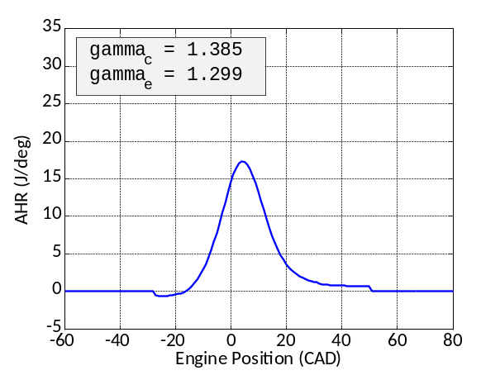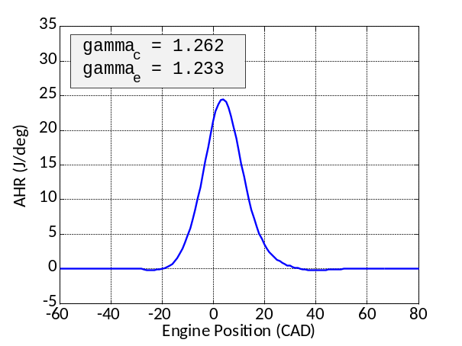
Figure V.A. AHR Curves with (LHS) gamma transitioned from the values determined from log(p) log(V) analysis and (RHS) gamma transitioned with value improved to have AHR trend to zero at start and end of combustion.

From the analysis in part V.A. above

Plot the integrated and normalize AHR producing the MFB as shown in Figure V.B. Overlay the MFB curves for the three tests.

Additionally complete the table below (replacing the values for test 623) giving the specific values of γ used in your analysis

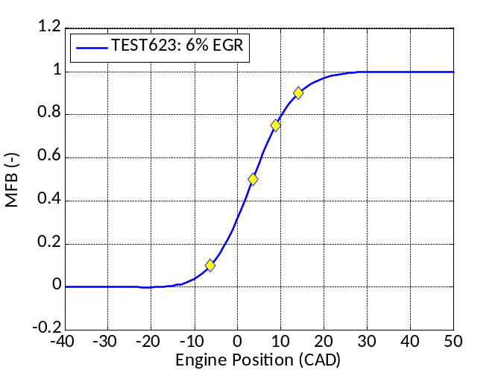
Figure V.B. Include a figure like this with legend
overlaying the three MFB curves for the three tests.

Table V.B. Summary of MFB analysis
Complete this table replacing your values over test 623
and inserting values for test 626 and 631.
Parameter | Unit | Test 623  6% EGR | Test 626  18% EGR | Test 631  28% EGR
γ_{c} | (-) | 1.262
γ_{e} | (-) | 1.232
CA10 | (CAD) | -6.3
CA50 | (CAD) | 3.5
CA75 | (CAD) | 8.8
CA90 | (CAD) | 14.1
CA10-90 | (CAD) | 20.4

Fit a Wiebe Function to the heat release

Apply a method to fit the Wiebe function with a = 2.303 to the MFB data for the three test cases.

Describe the method used to fit the Wiebe parameters (CA_{00,} CA₀₀₋₉₀, and m) to the data.

Plot the fits two each data set in individual plots

Complete Table VI.A.3 below – inserting your fit into test 623 and finding values for 626 and 631.
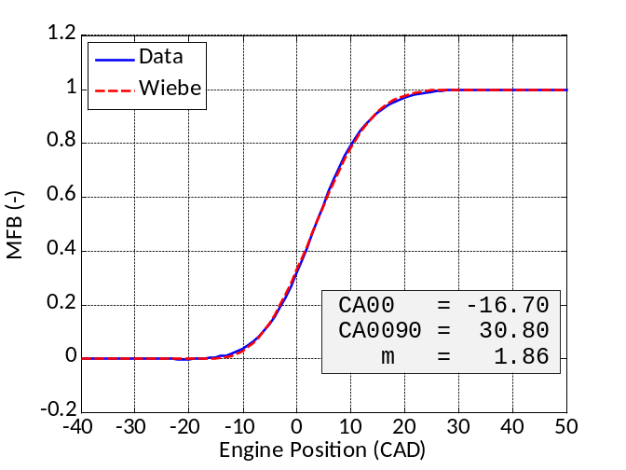
Figure VI.A.2: Plot MFB from analysis and Wiebe function fit.
Plot each data set in individual plots so there should be three plots.

Table VI.A.3: Wiebe fit parameters

Parameter | Unit | Test 623  6% EGR | Test 626  18% EGR | Test 631  28% EGR
CA00 | (CAD) | -16.70
CA0090 | (CAD) | 30.80
m | (-) | 1.86
a | (-) | 2.303 | 2.303 | 2.303

References figures for above – this is a three column format with 0.1” spacing.
Use this format with one column for each of the three tests (623, 627, and 632).

Part I
Test 623 (6% EGR)
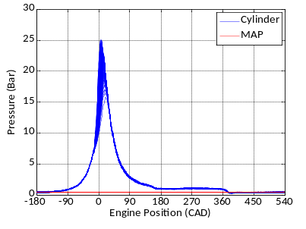
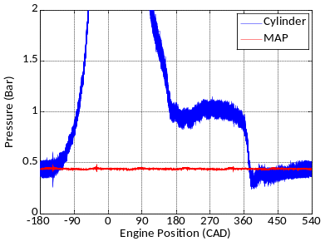
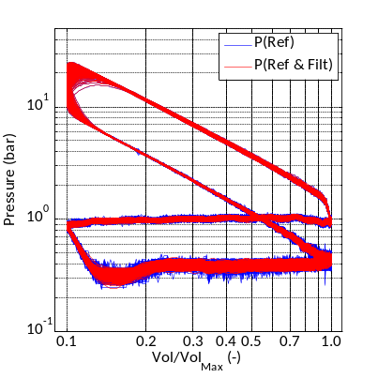
Figure 1a: Test 623 MBT spark timing, 0% EGR

Part I
Test 626 (18% EGR)

Fill in three plots here.
Part I
Test 632 (28% EGR)

Fill in three plots here.
Part II
Cycle Averaged
Test 623 (6% EGR)

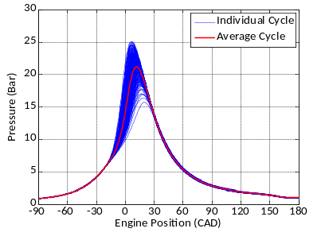
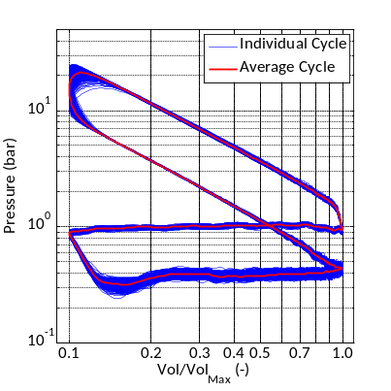
Figure 2a: Test 623 MBT spark timing, 0% EGR – Cycle Averaged
Part II
Test 626 18% EGR)

Fill in two plots here.
Part II
Test 631 (28% EGR)

Fill in two plots here.

References
- Heywood,J.B., Internal Combustion Engines Fundamentals, McGraw-Hill Inc, 1988.
- Lancaster, Krieger and Lienesch, “Measurement and Analysis of Engine Pressure Data,” SAE Technical Paper 750026.
Format for Submission
This is to be in the report format with the following sections. Submit a hard copy of the report in class (on-campus only) and submit electronic copies of the report and analysis codes in a single ZIP file with the name
LASTNAME.MEEM 5250.Assignment.05.zip
to Canvas by the dates and times indicated on the first page. Distance learning students only need to submit the electronic version.
I. Cover sheet
Homework title and number
Name
Date
Portrait picture.
II. See above for needed sections
- Appendix: Calculations and or other documentation/explanation of work
- Include your last name and page number at the bottom of the page in the footer.
- Include the grade sheet (below) as the last page on your report.
Grade Sheet

Student Name: Fill this in .

Area | Points | Score
Cover Sheet | 5
Introduction | 5
Parts I-VI (20 points each, 15 points for figures and tables and 5 points for discussion and explanations of method).
Part I | 20
Part II | 20
Part III | 20
Format for Report & Code – following submission  instructions | 10
Total Parts (I-III) | 80
Part IV | 20
Part V | 20
Part VI | 20
Format for Report & Code – following submission  Instructions | 10
Total Parts (IV-VI) | 70
Total = | 150

See also Lancaster, Krieger and Lienesch, “Measurement and Analysis of Engine Pressure Data,” SAE Technical Paper 750026.
Thanks to Wei Chen and the other graduates students who setup the engine, took this data and prepared it for this assignment.
Based upon a BMEP of 2.62 bar.

